**TASK # 1:**

**Create webservices for using calculator funtions using url such.as (Add 🡪 Multiply 🡪 Divide 🡪 Subtract … etc)**

**CODE:**

**WebService:**

using System;

using System.Collections.Generic;

using System.Linq;

using System.Web;

using System.Web.Services;

namespace WebApplication1

{

/// <summary>

/// Summary description for WebService1

/// </summary>

[WebService(Namespace = "http://tempuri.org/")]

[WebServiceBinding(ConformsTo = WsiProfiles.BasicProfile1_1)]

[System.ComponentModel.ToolboxItem(false)]

// To allow this Web Service to be called from script, using ASP.NET AJAX, uncomment the following line.

// [System.Web.Script.Services.ScriptService]

public class WebService1 : System.Web.Services.WebService

{

[WebMethod]

public string HelloWorld()

{

return "Hello World";

}

[WebMethod]

public double Add(double num1, double num2)

{

double tot = num1 + num2;

return tot;

}

[WebMethod]

public double Sub(double num1, double num2)

{

double tot = num1 - num2;

return tot;

}

[WebMethod]

public double Mul(double num1, double num2)

{

double tot = num1 * num2;

return tot;

}

[WebMethod]

public double Div(double num1, double num2)

{

double tot = num1 / num2;

return tot;

}

}

}

**Operations:**

protected void Button1_Click(object sender, EventArgs e)

{

double answer = 0.0;

ServiceReference1.WebService1SoapClient s = new ServiceReference1.WebService1SoapClient();

string select = DropDownList1.SelectedValue;

if (select.Equals("Add"))

{

answer = s.Add(double.Parse(TextBox1.Text),double.Parse(TextBox2.Text));

}

else if (select.Equals("Subtract"))

{

answer = s.Sub(double.Parse(TextBox1.Text), double.Parse(TextBox2.Text));

}

else if (select.Equals("Multiply"))

{

answer = s.Mul(double.Parse(TextBox1.Text), double.Parse(TextBox2.Text));

}

else if (select.Equals("Divide"))

{

answer = s.Div(double.Parse(TextBox1.Text), double.Parse(TextBox2.Text));

}

Label1.Text = answer.ToString();

}

**OUTPUT:**

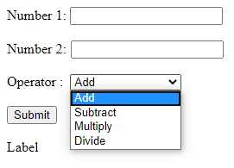

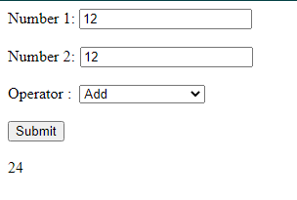

**TASK # 2:**

**Create webservice for converting xml to json 🡪 the service take input xml as a string and return json converted output of that xml.**

**CODE:**

using System;

using System.Collections.Generic;

using System.Linq;

using System.Web;

using System.Web.Http;

using System.Web.Mvc;

using System.Web.Optimization;

using System.Web.Routing;

namespace XML_to_JSON

{

public class WebApiApplication : System.Web.HttpApplication

{

protected void Application_Start()

{

AreaRegistration.RegisterAllAreas();

GlobalConfiguration.Configure(WebApiConfig.Register);

FilterConfig.RegisterGlobalFilters(GlobalFilters.Filters);

RouteConfig.RegisterRoutes(RouteTable.Routes);

BundleConfig.RegisterBundles(BundleTable.Bundles);

GlobalConfiguration.Configuration.Formatters.XmlFormatter.SupportedMediaTypes.Clear();

}

}

}

using System;

using System.Collections.Generic;

using System.Linq;

using System.Net;

using System.Net.Http;

using System.Web.Http;

namespace XML_to_JSON.Controllers

{

public class ValuesController : ApiController

{

// GET api/values

public IEnumerable<string> Get()

{

return new string[] { "Arbab", "Arain" };

}

// GET api/values/5

public string Get(int id)

{

return "value";

}

// POST api/values

public void Post([FromBody]string value)

{

}

// PUT api/values/5

public void Put(int id, [FromBody]string value)

{

}

// DELETE api/values/5

public void Delete(int id)

{

}

}

}

**OUTPUT:**

**Input:**

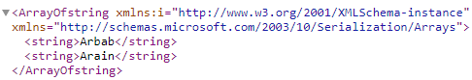

**Conversion:**

